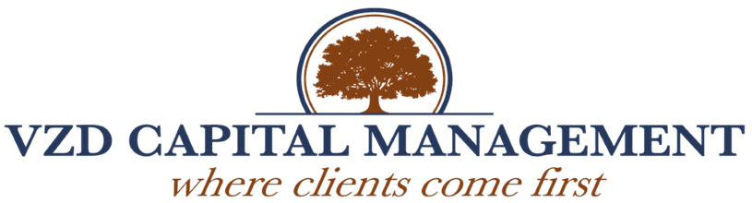

TO: VZD Capital Management Clients and Prospects
FROM: Ethel J. Davis, CEO
Nikisha L. Johnson, Executive Mentoring Candidate
RE: 2021 Compliance Standards
DATE: June 29, 2021
Client Initials: ___________________________________________

___________________________________________

Thank you for your continued patronage with VZD Capital Management, LLC. We appreciate the trust, confidence, and patronage you have placed in us. Per the annual compliance standards, the Securities and Exchange and State Commissioners requires Registered Investment Advisory firms to provide a detailed brochure about the business and the firm’s owner. The booklet consists of two parts, the ADV Part 2A and 2B, plus the Privacy Policy, which includes information about the business, fees and compensation, and any disciplinary events regarding the firm or owner.

We came through a tumultuous year, and we received $3,442 in the Paycheck Protection Program as a precaution for the unknown and uncertainty surrounding the pandemic environment. We believe in transparency but wanted to ensure our small boutique family that the firm is financially healthy but applied for the loan as a precaution for what the stock market might do considering the economic lockdown. Fortunately, the market expanded, and our firm grew throughout this unprecedented season.

The State of Kansas Commissioners conducts an audit periodically to ensure we have met the requirements and standards set forth by the Securities and Exchange Commission. We are proud to announce we passed with flying colors in every aspect of the assessment. However, we did discuss the fee schedule and referenced that we “grandfathered” all of our clients at .80 basis points from the inception date of the firm. We will adjust the fees based upon the investable assets under management, which will affect everyone’s quarterly amount slightly.

Please sign and initial the Discretionary Investment Agreement acknowledging that you were made aware of such change, and if you have any questions or concerns, you will call me directly at (816) 726-7066. We do not charge commissions or even an initial consultation fee unless it involves research or a detailed assessment of your holdings. We have not changed or increased the prices since the inception date of the firm being December 2012. Our short and long-term goals are to implement new software and future hires for administrative and operational positions.

Thank you for being a member of our VZD family, and we look forward to our continued partnership with our valued clients. Upon completion, please return the Acknowledgement in the enclosed courtesy envelope for your immediate consideration and review.

