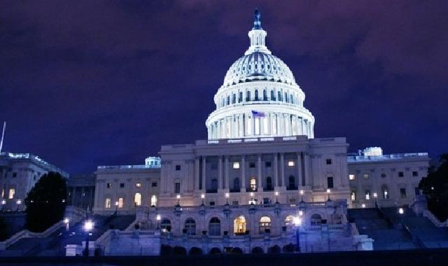

NEW DIRECTIONS: RAPIDLY CHANGING WORLD

Even with highly-developed technology and online capabilities that connect people thousands of miles away in milliseconds, it still isn’t possible to know exactly what the future will hold. As the philosopher Peter Drucker once said, “trying to predict the future is like trying to drive down a country road at night with no lights while looking out the back window.” As recent political and economic surprises have demonstrated, one simply cannot predict the future.

One of the biggest surprises this year may be how staid the markets have remained regardless of news, global events and economic data. Many feared that the presidential change, including the tweeting and political rhetoric during the campaign, could have a major impact on the market’s performance. We have witnessed senior administration resignations, FBI investigations and changes of heart regarding military involvement in Syria. Even so, the S&P 500 index grew earnings by 6.1 percent while emerging markets, along with developed markets in Europe and Japan, performed even better.

The Federal Reserve raised short term interest rates by 0.25 percent in March, the second increase since December 2015 and an indication that the Fed believes the US economy is improving and making progress toward its objectives of full employment and price stability. Interest rates remain low by historic standards and corporate earnings are a likely reason that U.S. equity markets have rallied since the election. As we witnessed from the recent attempt to pass new healthcare legislation, the legislative process is often difficult to predict, making it nearly impossible to know what, if any, new legislation may result. This creates a great deal of uncertainty in forecasting after-tax corporate earnings and fair values for stocks.

Historically, a globally diversified equity portfolio often performs better than a strictly US portfolio. However, over the last six calendar years, both developed and emerging overseas markets have been more attractively valued compared to the US. Emerging markets are also significantly undervalued compared to the US, however their corporate earnings could be adversely affected by the strengthening of the US dollar, rising interest rates and potential US trade tariffs. Due to the many political uncertainties here and abroad, it would appear to be prudent to invest cautiously both in the U.S. and overseas depending on individual and collective investment risk tolerances.

In an environment where political news seems to cover most of the headlines, we hope you gain a deeper understanding of VZD Capital Management’s investment philosophy, using the value of the company and current market dynamics to guide our investment decisions. Our job is not only to attempt to separate fact from fiction but, even more importantly, to remain acutely aware of the elements that drive long-term value creation. Even though we are moving in a new direction, we still evaluate companies on their fundamentals and their institutional ownership, among other economic factors, and our commitment to our clients is unchanged. We build portfolios, company by company, which have the potential to provide competitive returns – one client at a time. We appreciate the trust and confidence you have placed in us.

Continued success and blessings – always!

Respectfully,
Ethel J. Davis & Associates
CEO | Portfolio Manager

Past performance is not guarantee of future results. No investment strategy can assure a profit or protect against loss.

